VMIS Instructions
How to Register and Apply for a Position in the Volunteer Management Information System (VMIS)
If not yet registered on VMIS, the following steps may be taken:
- Log onto www.myarmyonsource.com
- Register
  - Log in – Click on the Register Button on the top right. On the next page, scroll down to the bottom of the page and click the button that says Join Now.
  - Fill out the information requested, including creating a Username and Password. If you have a Username and Password for vFRG, the two sites are linked, so you would use the same information. The password has no requirements.
  - Fill out any information with an asterisk on it (*).
- Once Registered and logged in, Click on Volunteer Tools at the top right of the screen.
- To find your positon simply put your installation in the community filter then scroll down till you find “BOSS Volunteer” or other appropriate position. Click on that selection, on the next screen click apply.
- It will then show you your Volunteer Profile. Fill in any missing information and click Submit at the bottom of the application. You have now applied for the position.
- Wait for the Organization Point of Contact (OPOC) to approve your application.
- Once approved you can begin Logging in your hours. You have until the 15th of the following month to log in each months hours.
To log Hours Daily (Up to the 15th of the following month)
- Once logged in, click on Volunteer tools at the upper right corner of the screen.
- On the next screen, click on the Volunteer Activity tab.
- Under Open Services, click on the Hours button, located on the right of the position you are logging for.
- Click on the yellow box Add for Period
- On the next screen, input the information, then click on Save.
For guidance on OPOC capabilities, coordinate with your Army Volunteer Coordinator within ACS.
If you have any questions about the events or the VMIS website, ask the BOSS Team or your Army Volunteer Coordinator, or call the Help Desk.

Go to the IMCOM Training Center, School for Family and MWR Login page.

https://webtrac.mwr.army.mil/Kview/CustomCodeBehind/customization/login/mwra_login.aspx

If you don’t have a login, click the “Create New Account”, button in the bottom center of the screen.

Follow the prompts to complete the:
Consent
User Information
Supervisor/Training POC
Organization and Job Title sections

Once you receive the login information from the Registrar, login, and click on “Course Catalog” toward the top of the screen.
On the next screen enter “BOSS” in the “Search Text” box
You should get the following screen:
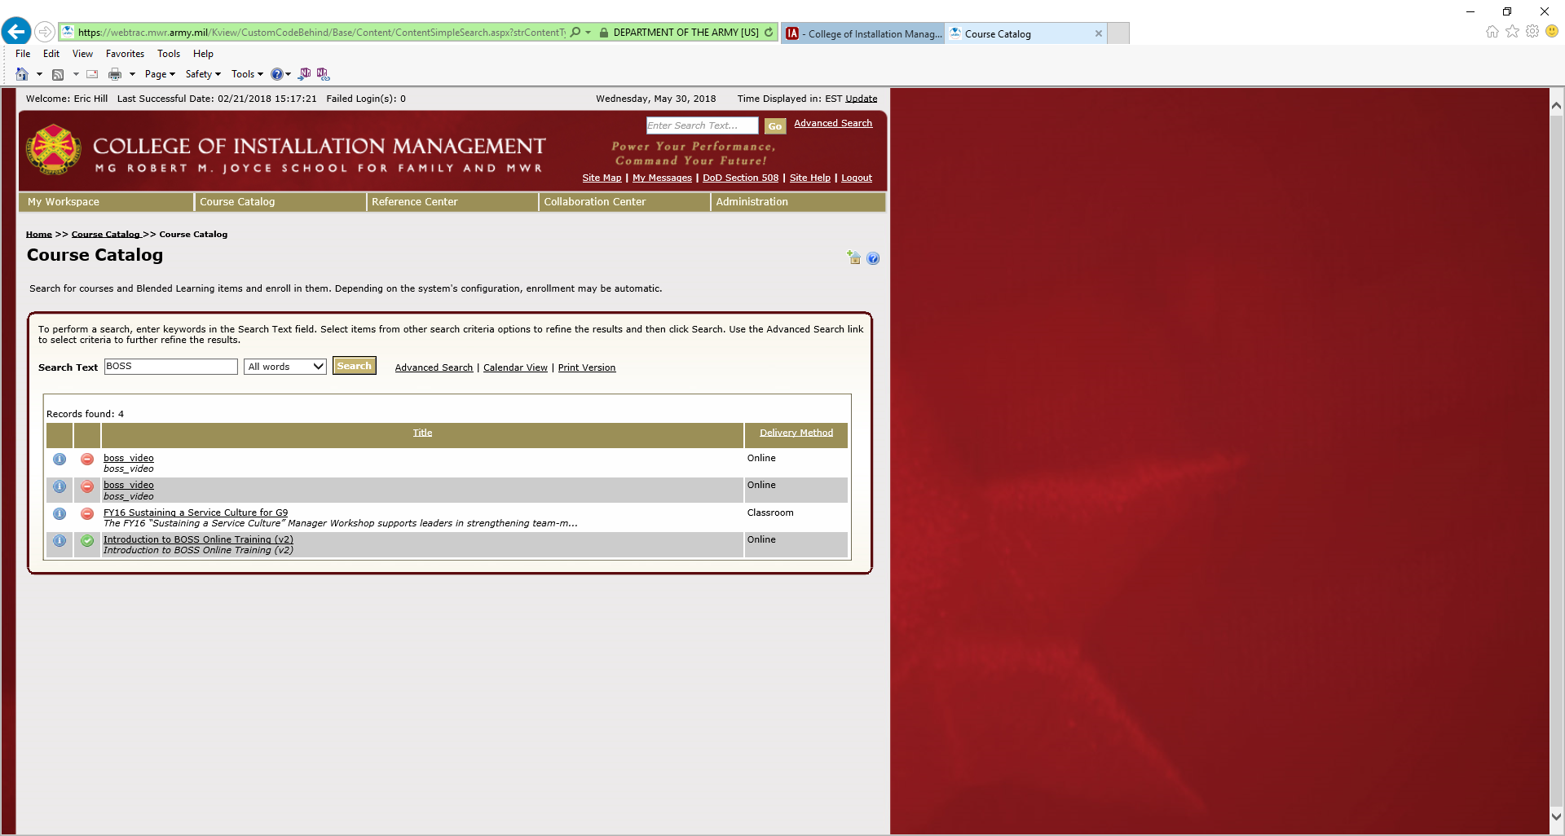
Click on introduction to BOSS Online Training.

On the next screen click on the Access Item button in the center of the screen.

This will open the training in another window.

Follow the prompts through the following modules:

