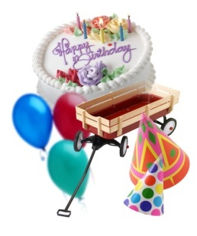
It’s Your Birthday!

Party Flow
1 hour - In-Center Activity

30 minutes - Food & Fun
• Dancing
• Balloon Animals
• Games

10 Minutes - Cake & Singing

10 Minutes - Presents (or more fun & games)

10 Minutes - Wrap Up/Big Finish
• Hand out game cards
• Reset for next party

Meet & Greet Checklist

Party Flow Card
Party Contract
Airline Style Welcome Sign
It’s My Birthday! Glow Button
Check Cake / Food Details

